DOM SELECTORS BEGINNERS STUFF

LEFT PE BASIC HTML FILE AND HOW WE CAN MANIPULATE IT USING CONSOLE

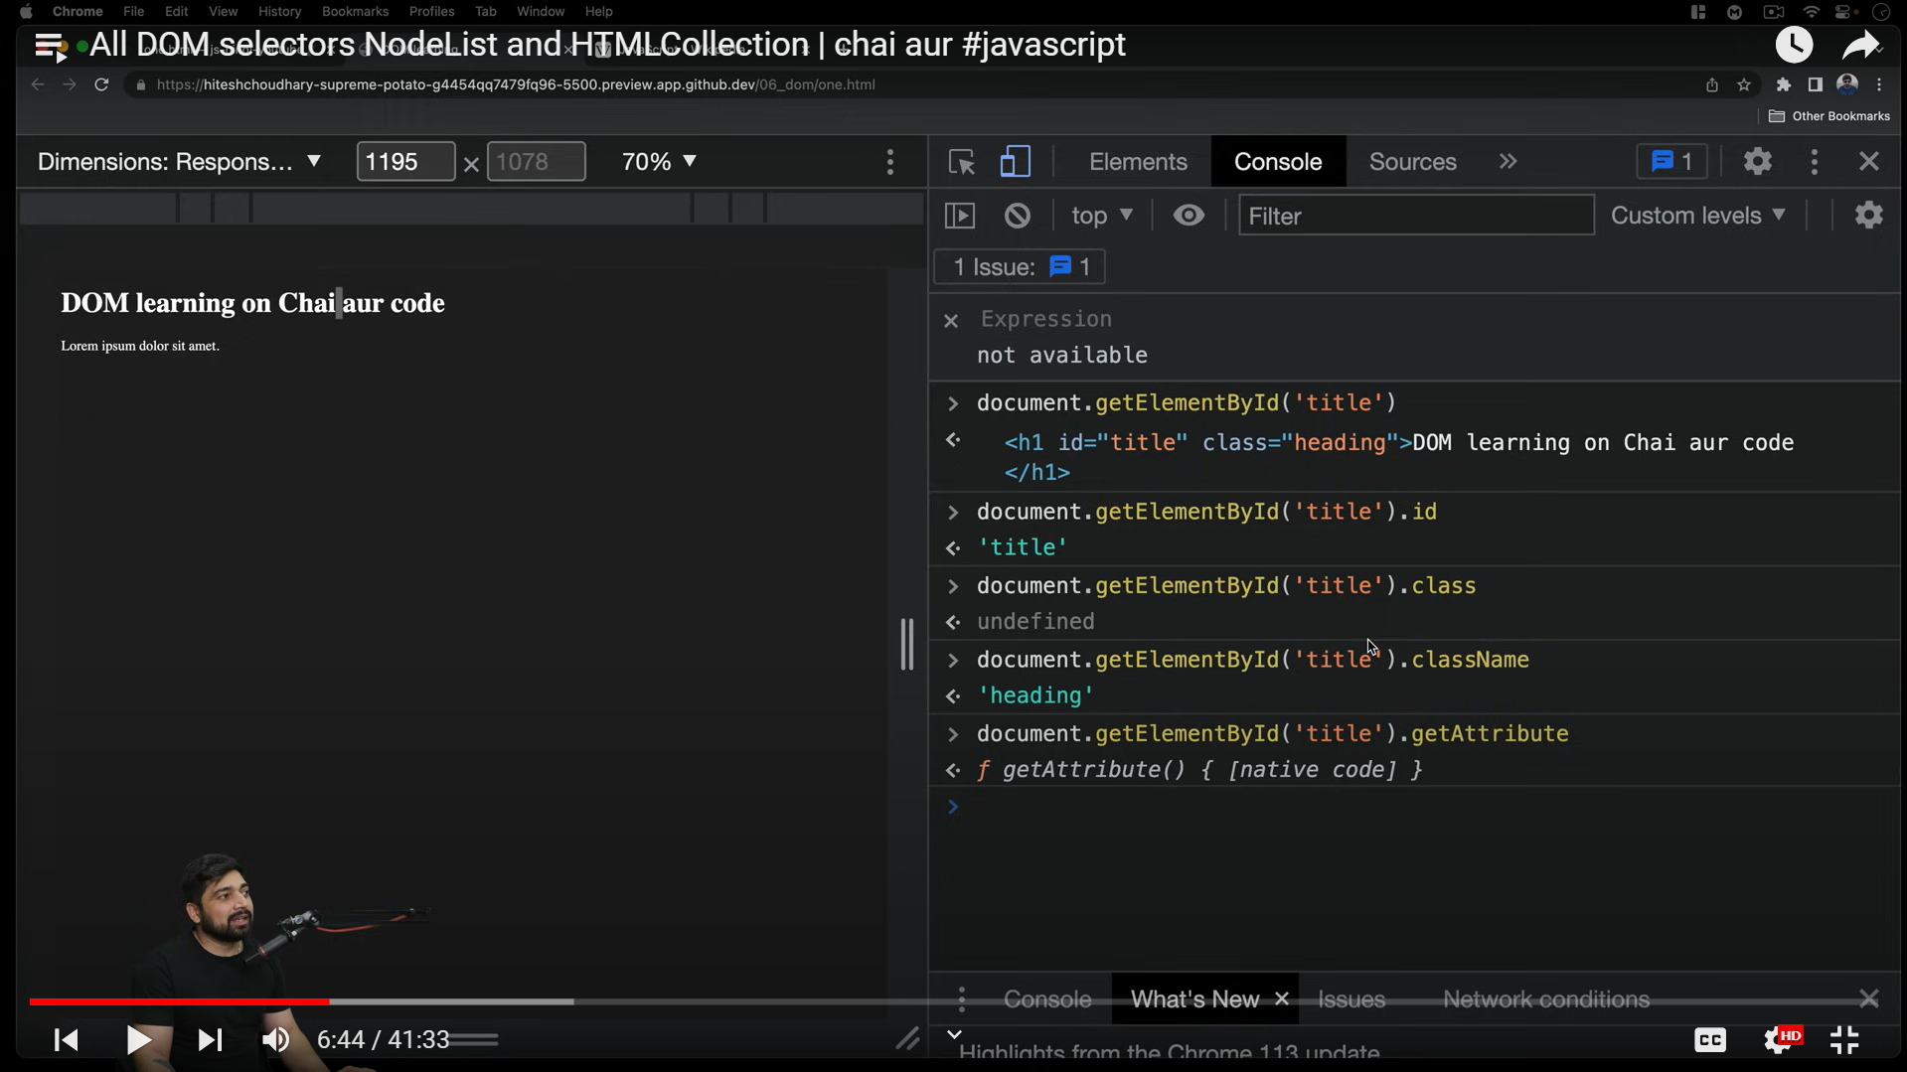

LAST LINE MAI WE PUT ELEMENT IN A VARIABLE CALLED TITLE FOR EASY ACCESS

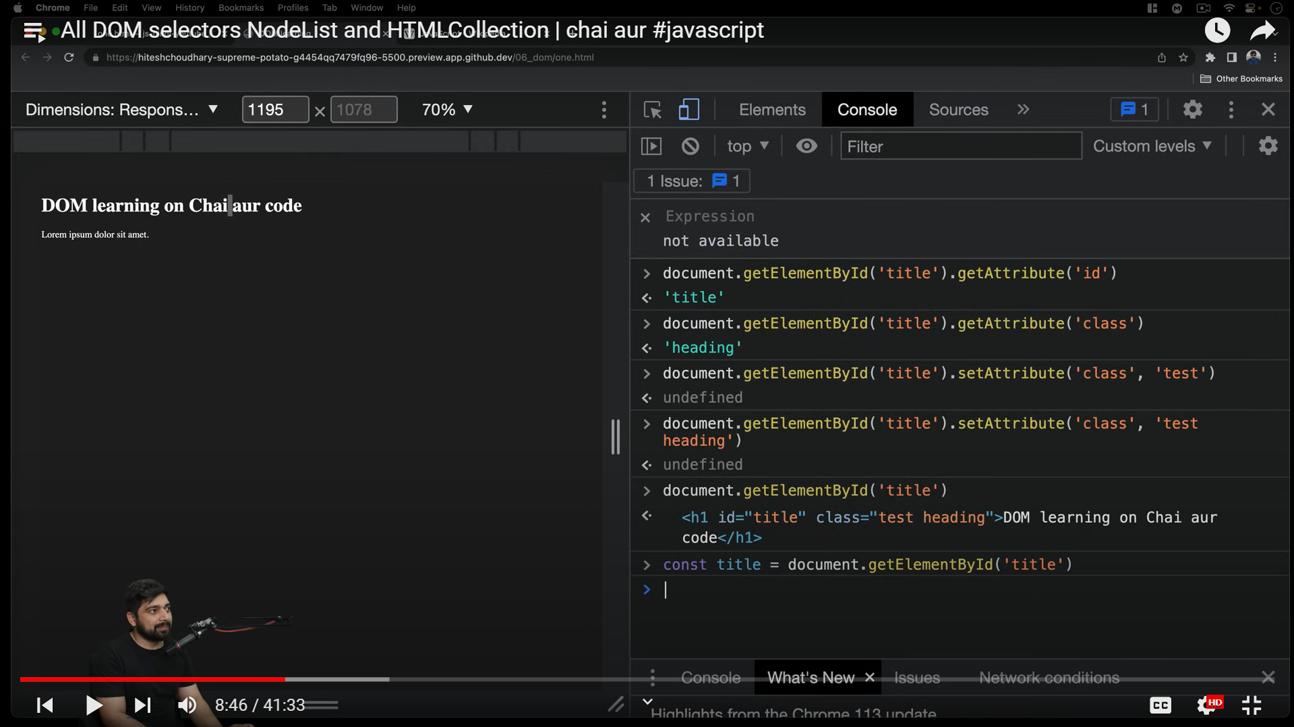

Using only title keyword to do stuff now

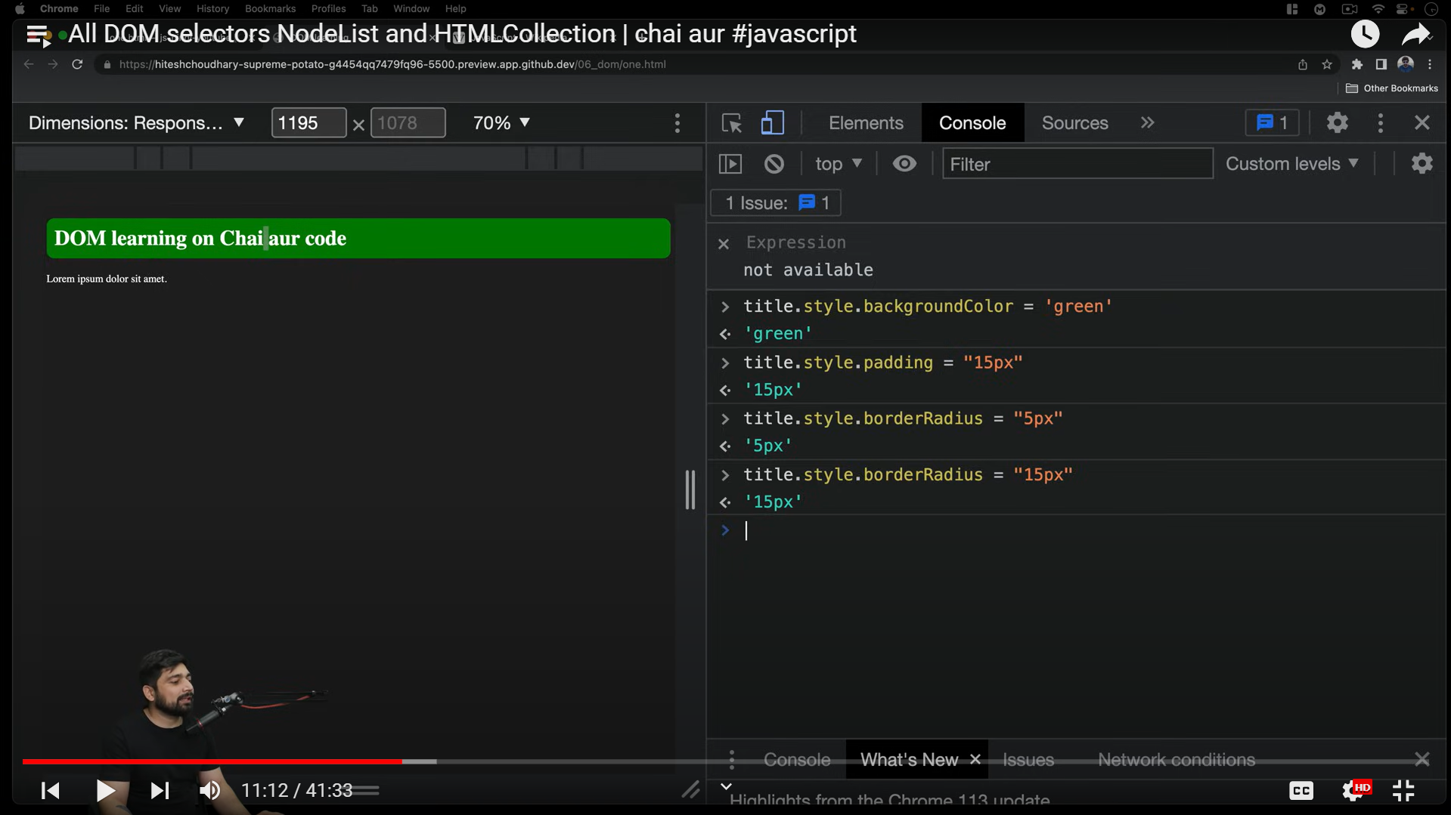

#INTERESTING

How content is added:-

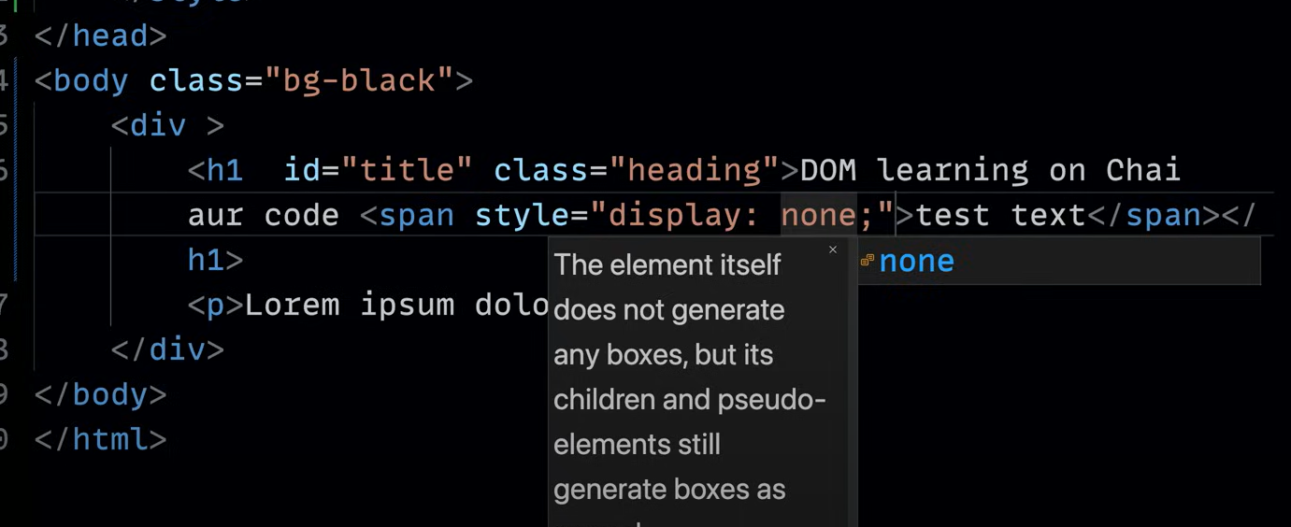

3 ways and are different as return different things:-

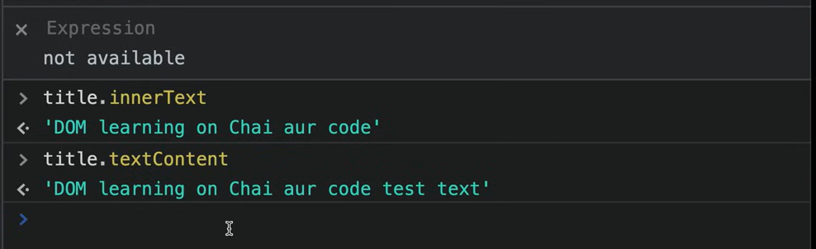

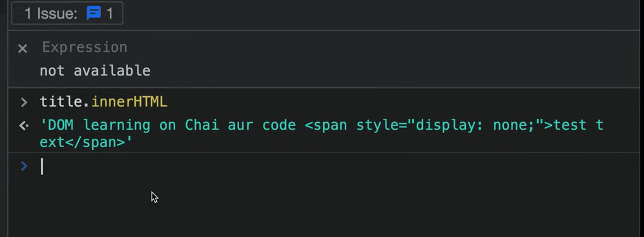

Another way to get elements

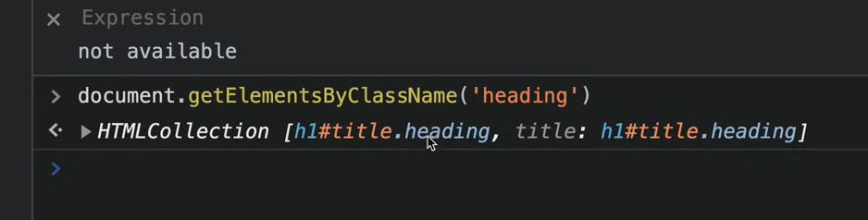

SELECTORS:-

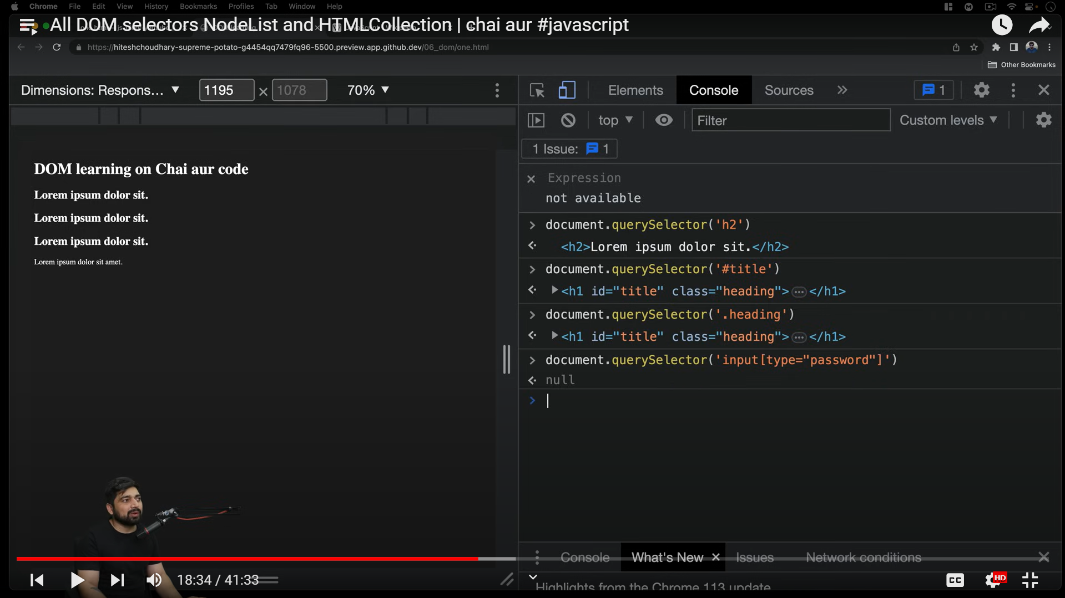

Jab input type password jaise hoga In html:-

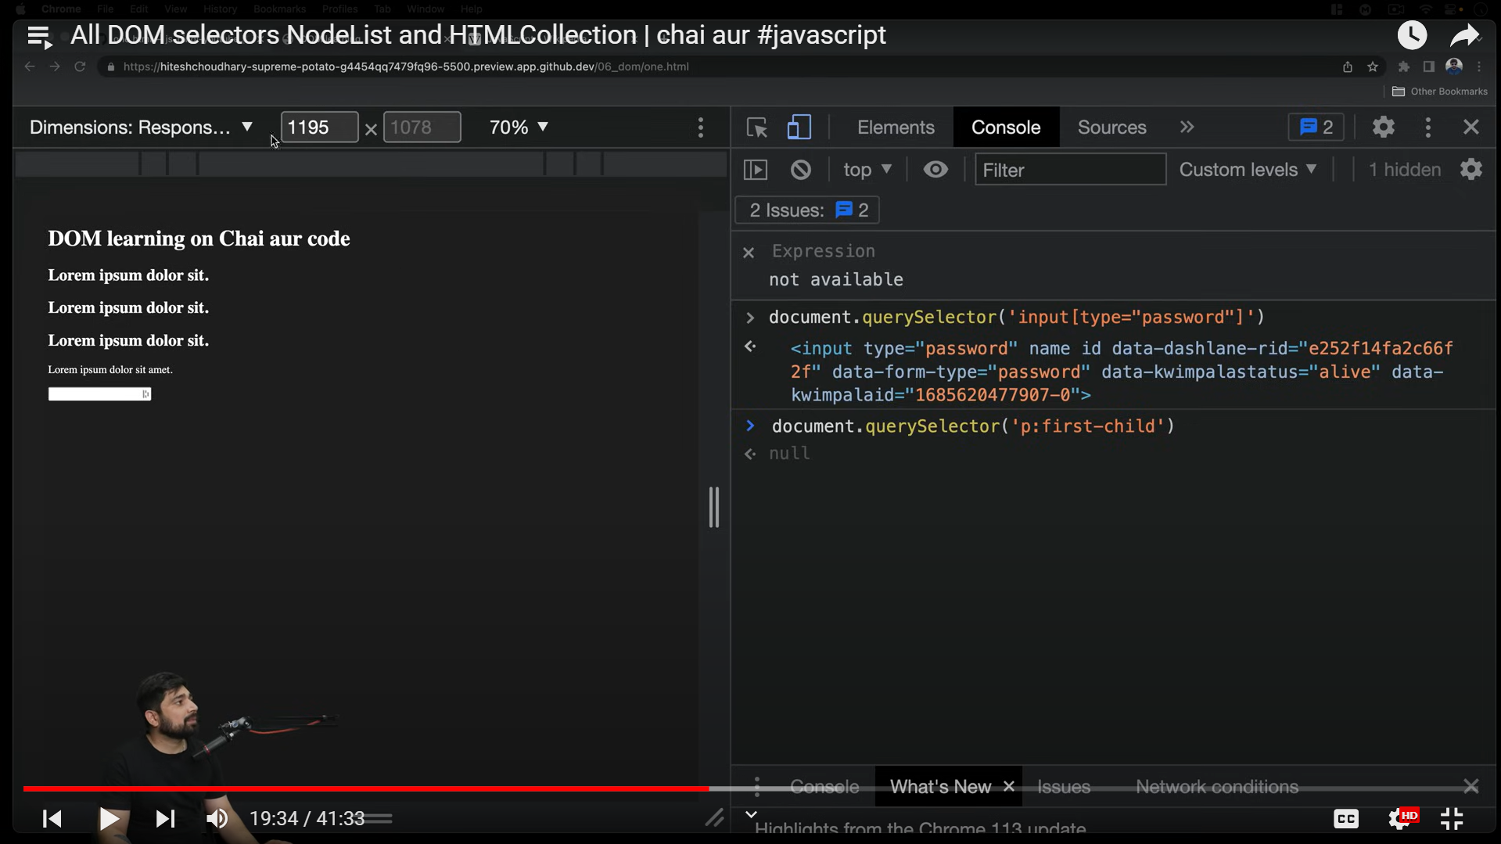

Created ul in html and chose first li as ‘queryselector’ choses the first of each type only

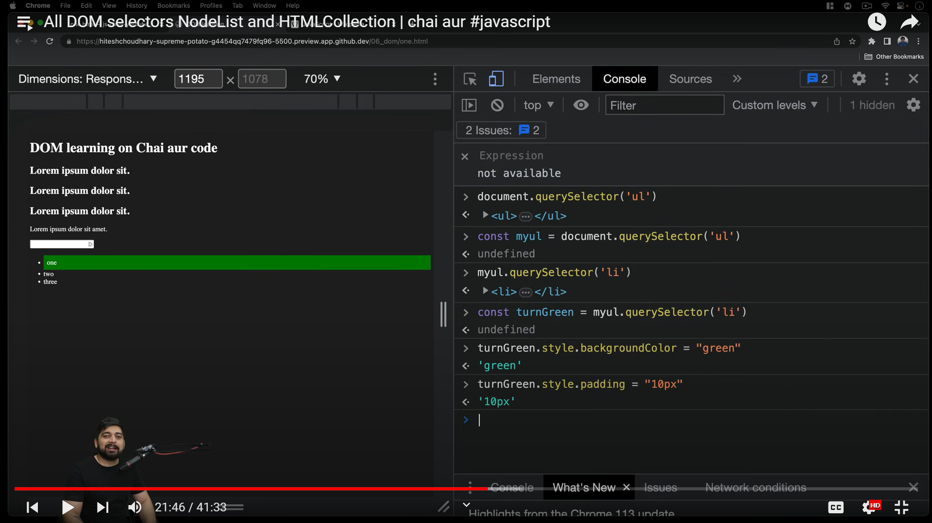

Changing text of first li:-

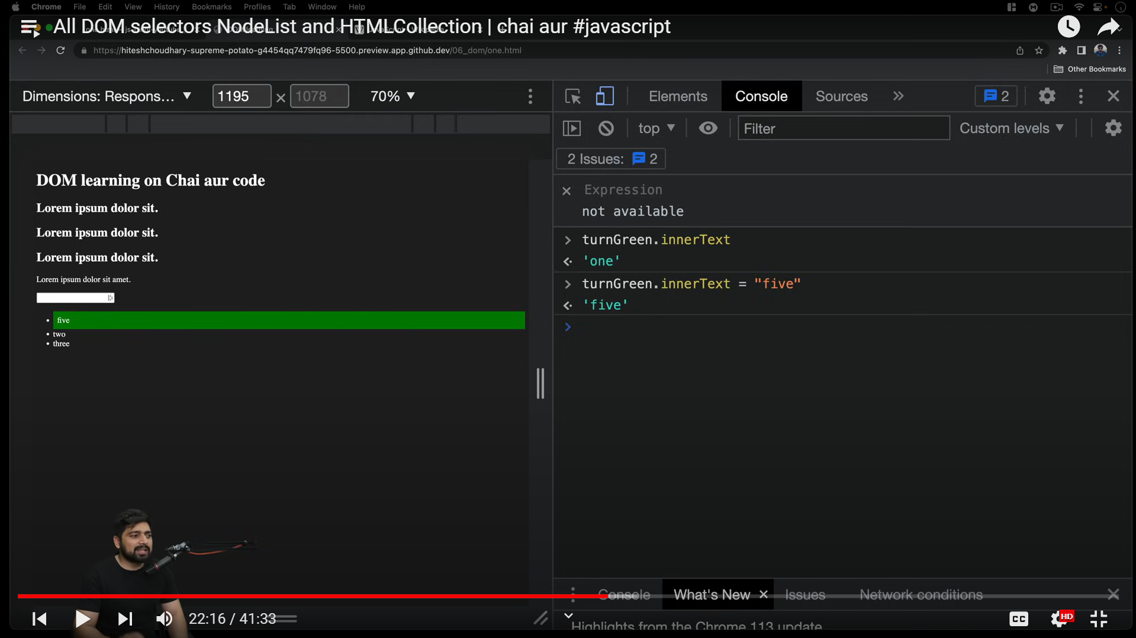

‘queryselctorall’

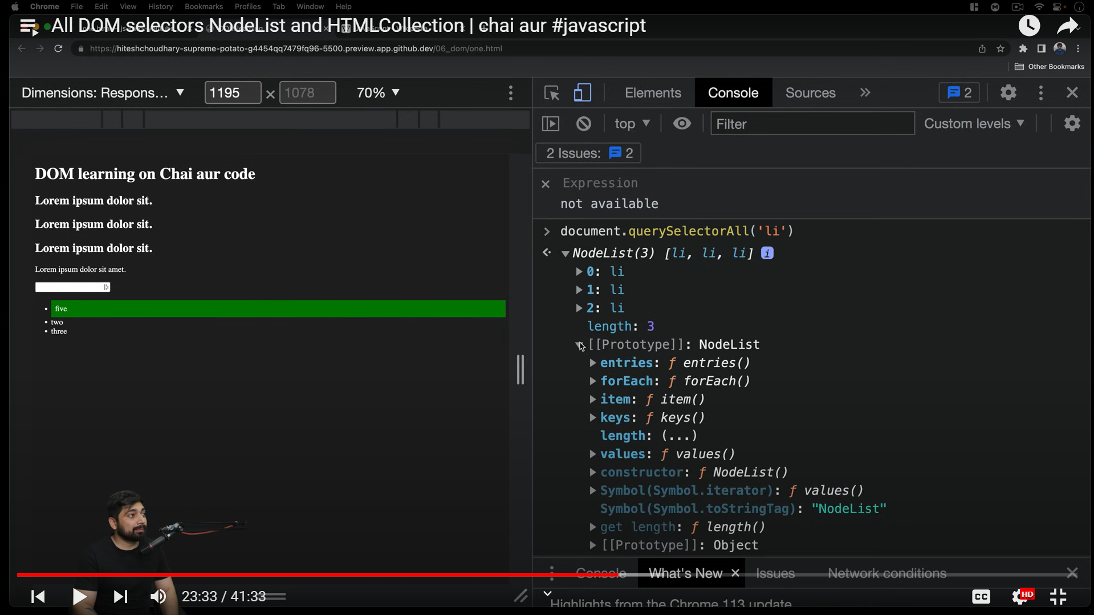

Returned is not a pure array as has only limited functions specified in prototype and array has maps, filter, reduce etc as well.

Manipulation using queryselectorAll:-

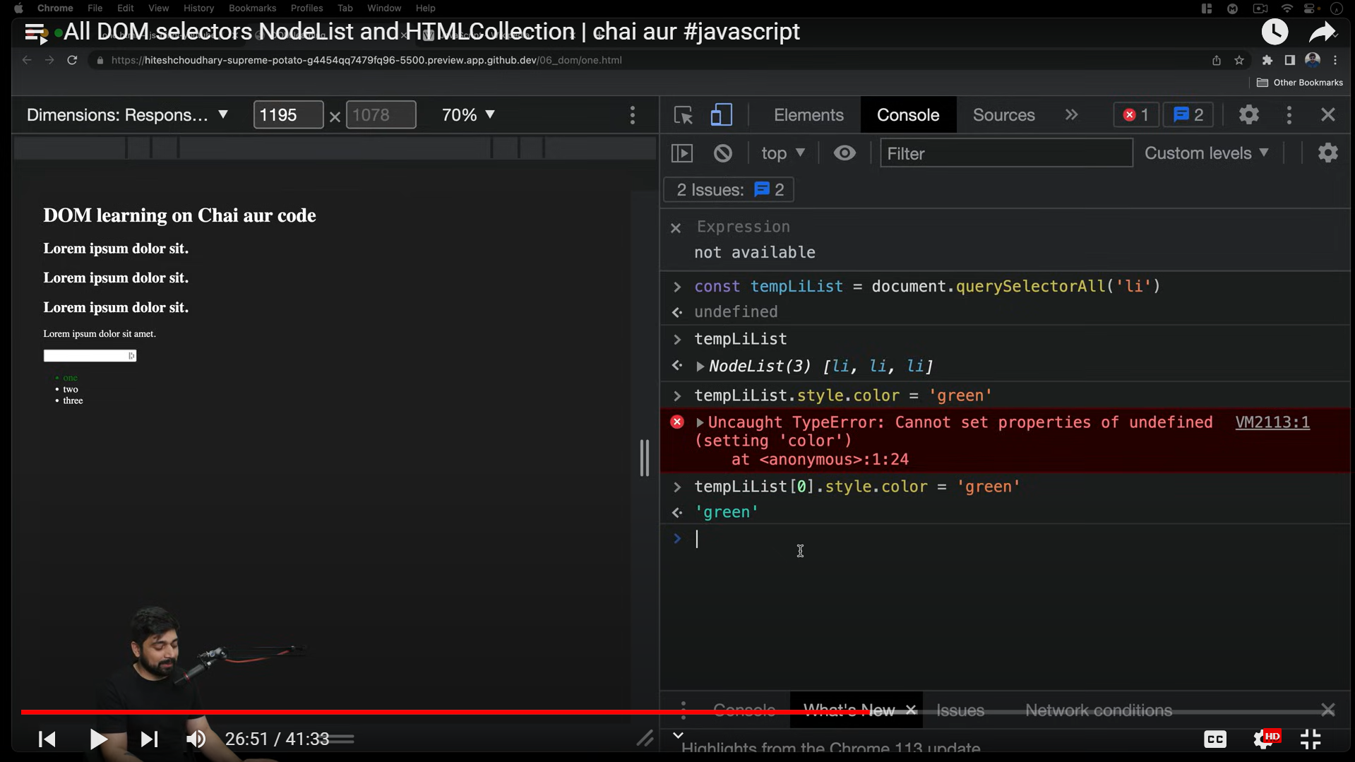

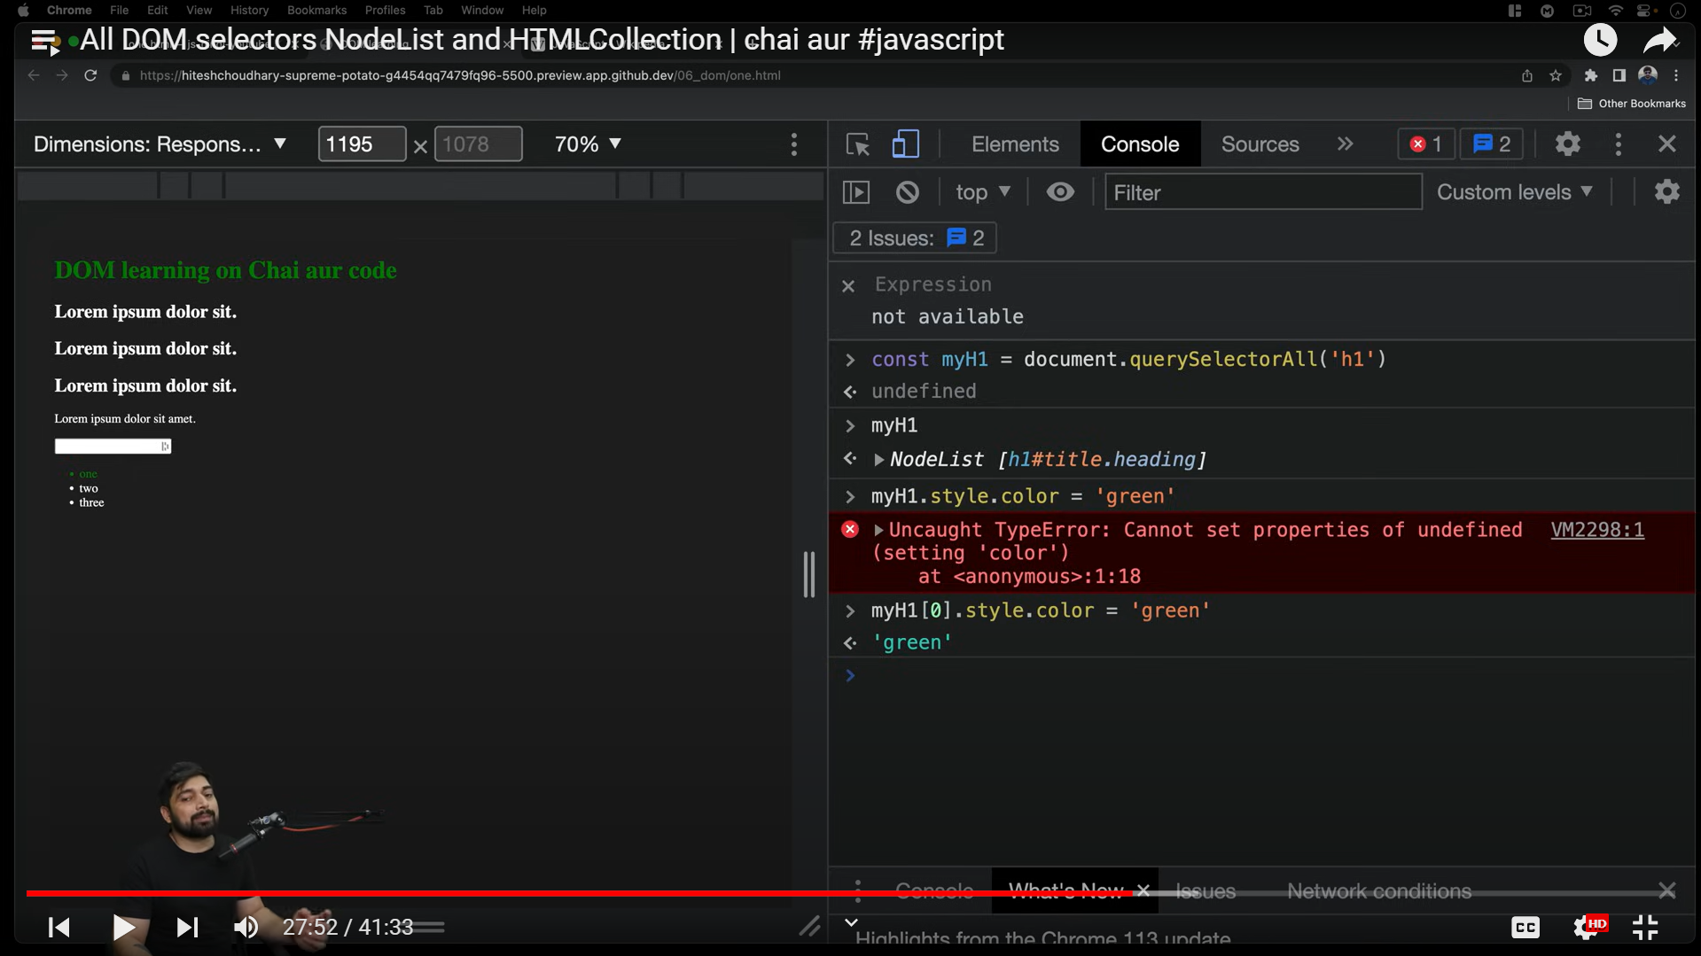

Foreach:-

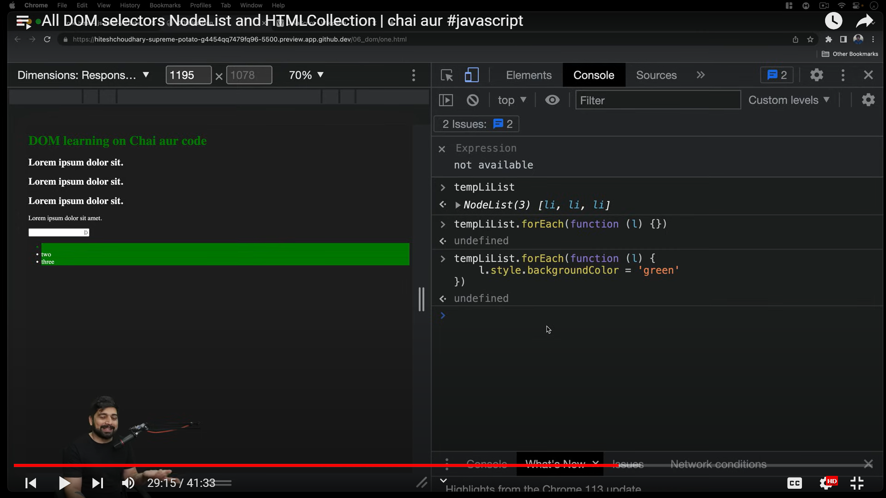

NODE LIST CAN BE CONVERTED TO ARRAYS TO OPEN FURTHUR MORE FUNCTIONALITIES.

NOW suppose iteration over same class name

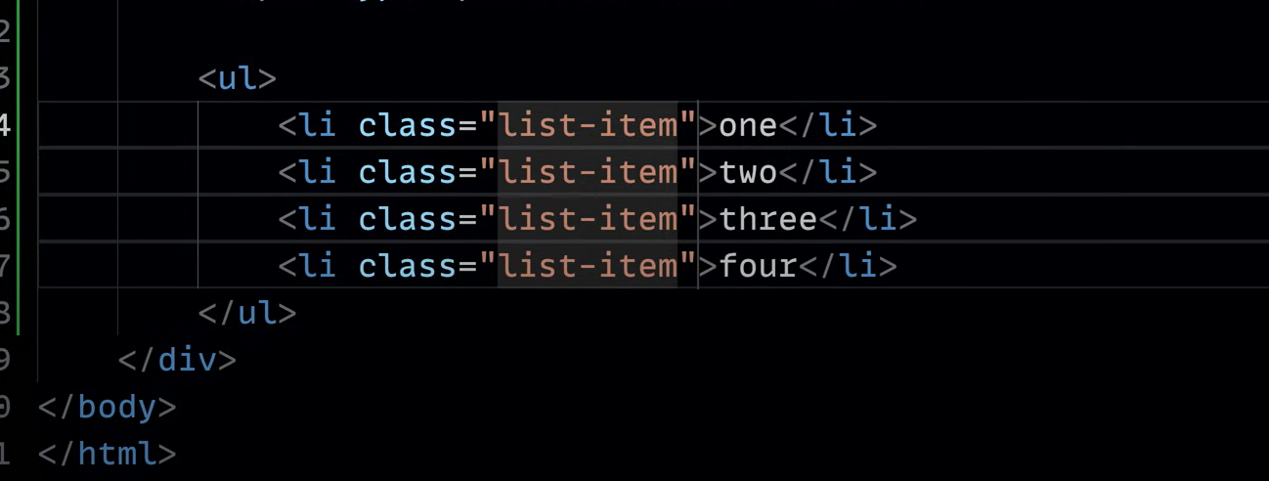

No method for looping

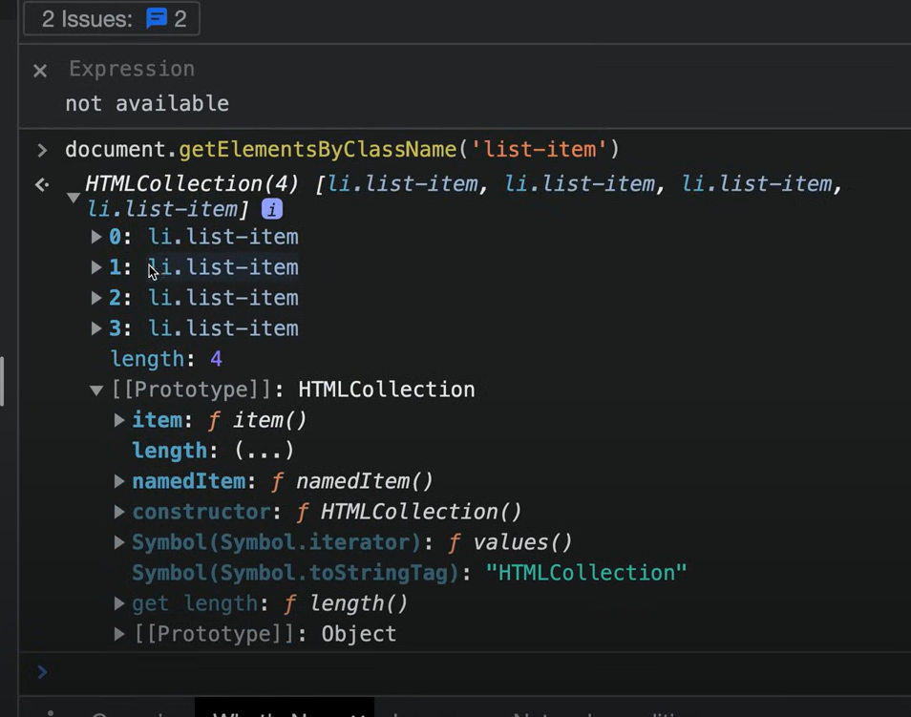

Cant use foreach for html collection

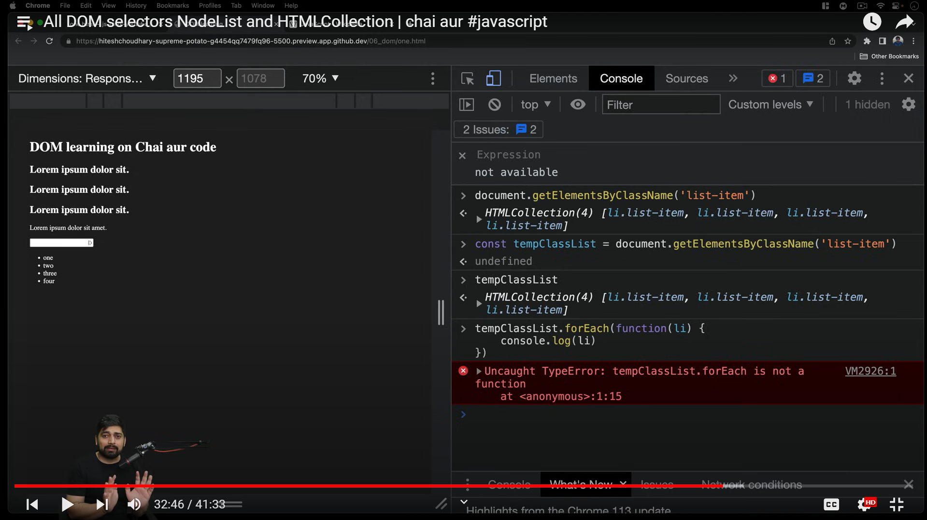

It must be first converted to a datatype jispe ye sabh easily ho sake

CONVERTED TO ARRAY NOW CAN DO ANY FUNCTION

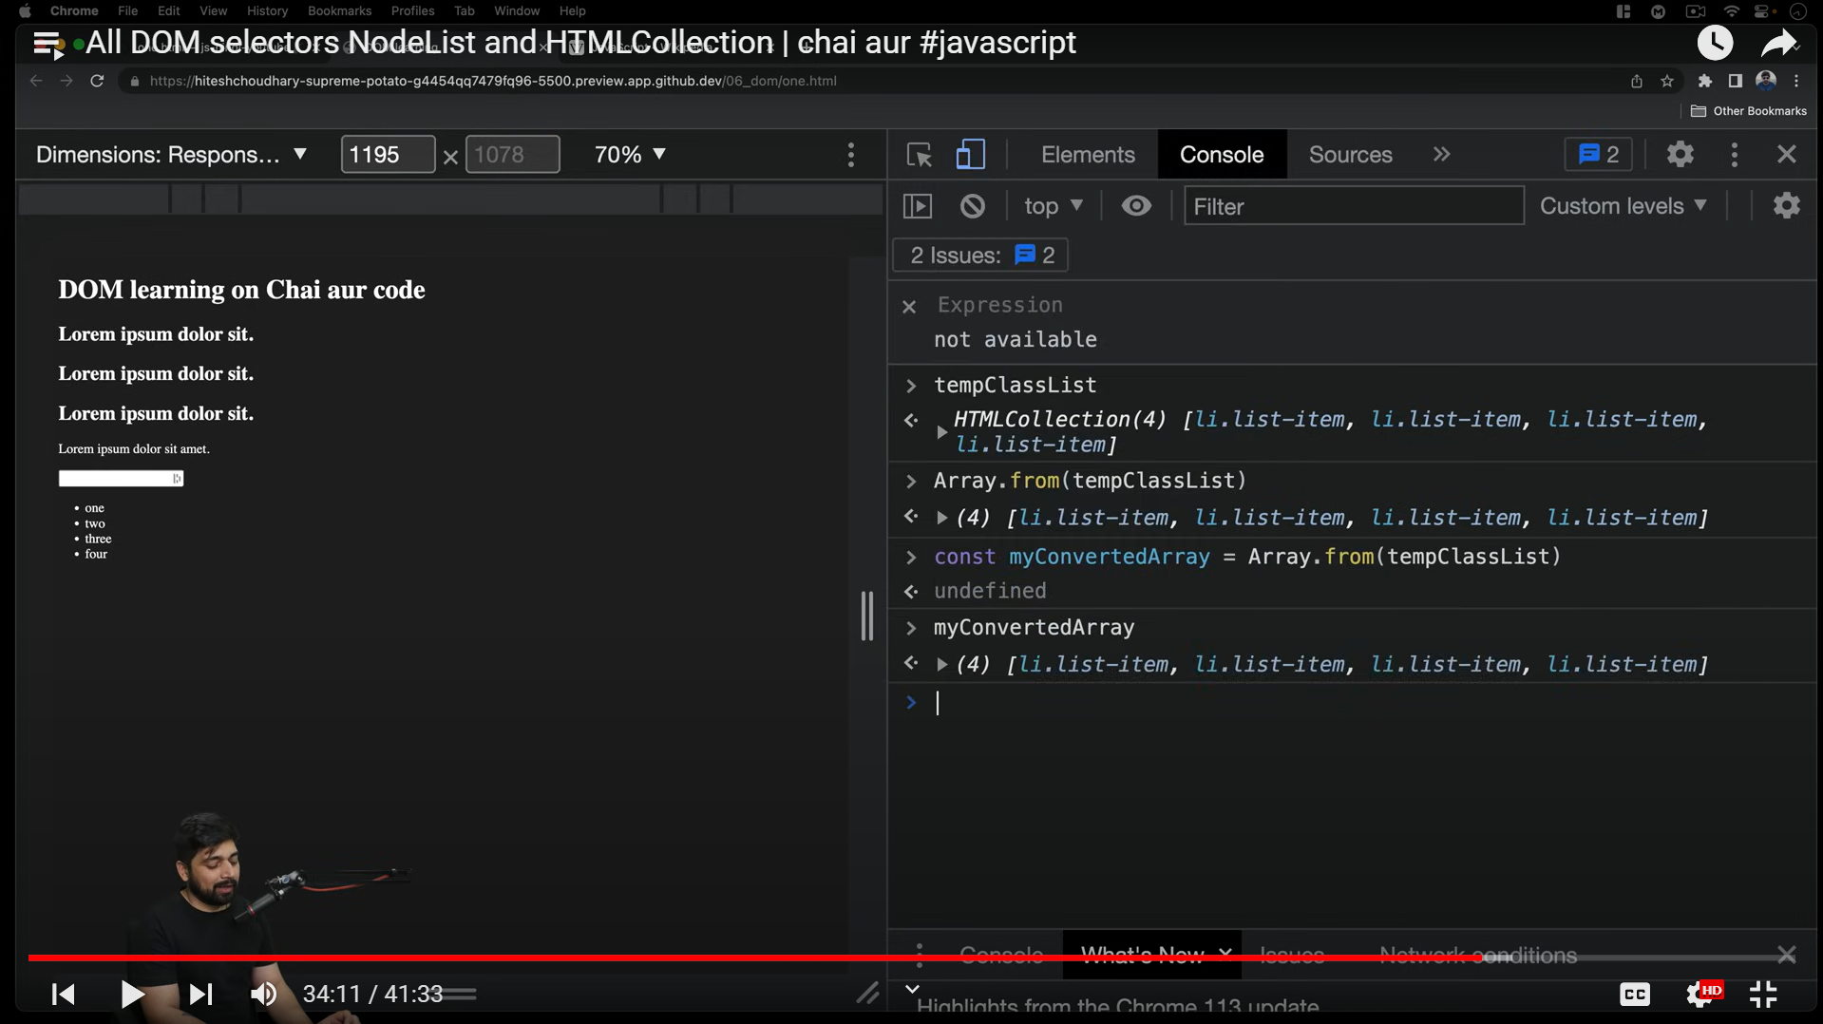

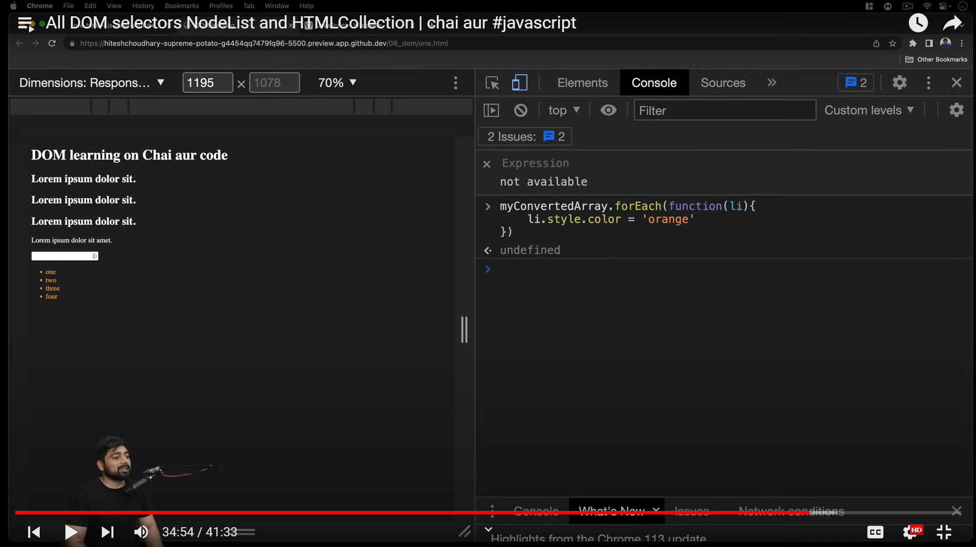

ACCESSING STUFF FROM RANDOM WEBSITE , I.E WIKIPEDIA

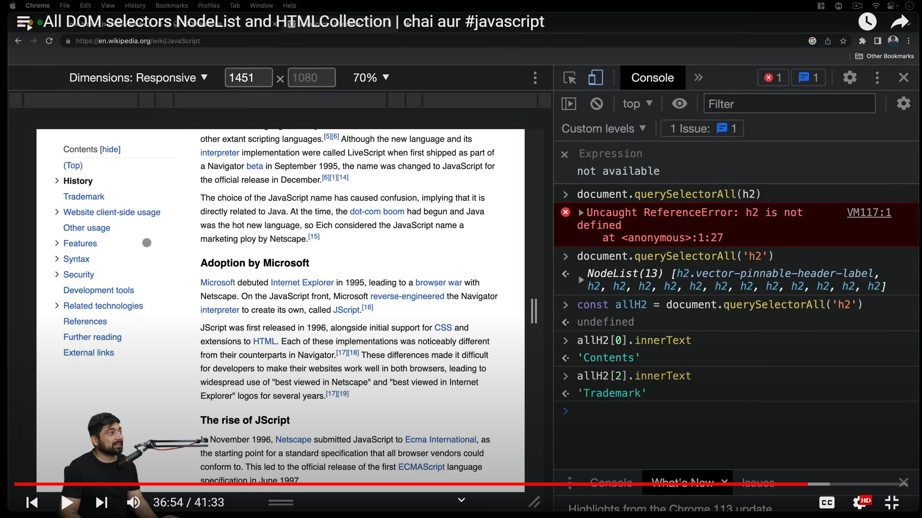

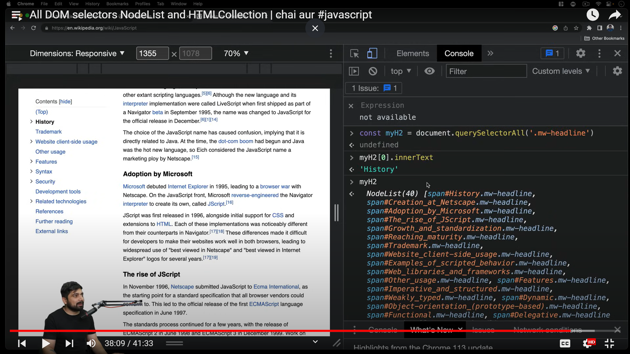

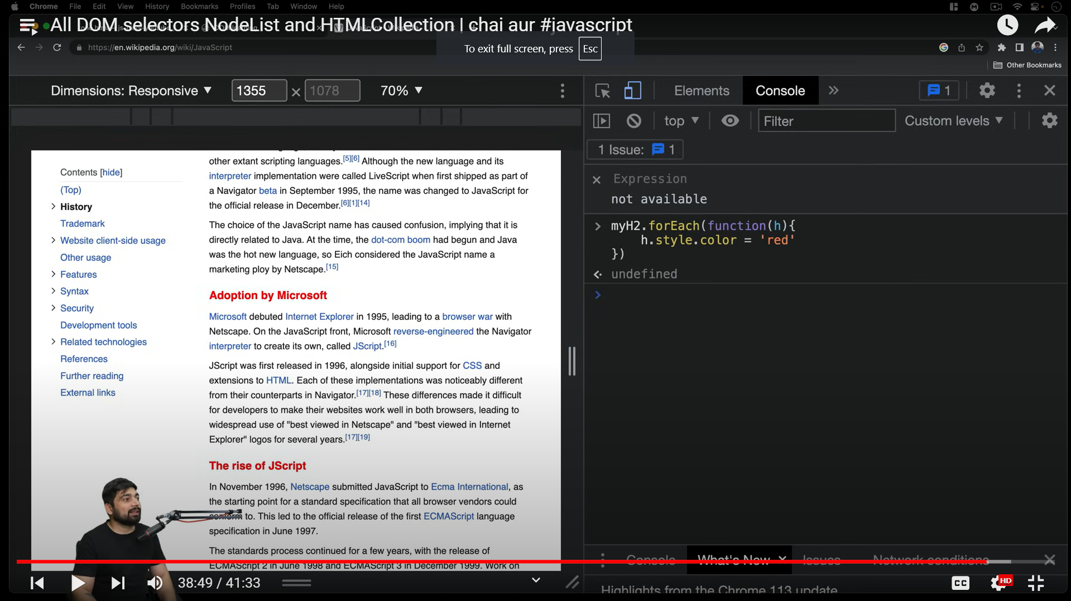

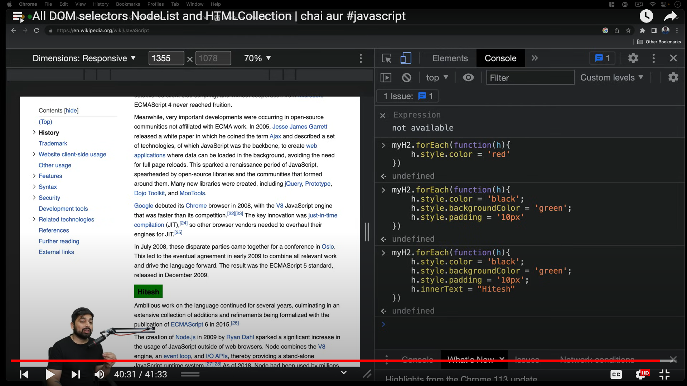

We have learnt to handle html collections, arrays and values of classes and html files dom from database ke basics a few ways to manipulate stuff.